## 1. INTRODUCTION

### 1.1 About the Organization



Sysfore Technologies was set up in 2004 in Bangalore in the early days of the dot-com bubble, by **Ajith Mathew George, Bobby Varghese,** and **Dinesh R.**Co-founder Ajith Mathew George was a technologist in his earlier avatar, while Bobby Varghese VP & Co-founder was on the business development side. The other co-founder Dinesh R is a third-generation entrepreneur with a passion for engineering.

In the early years, the focus was on custom-built .NET web applications and on the open platform using technologies using JSP, Servlets, J2EE etc. Later when the trends started shifting to Web 2.0, our solutions incorporated AJAX and lots of JavaScript for rich interfaces. During the same time, we started building solutions using more of the open-source technology stack like PHP, MySQL (LAMP stack), Magento based ecommerce stores, JOOMLA based content managed websites and the like. The last few years, we built our capabilities on the Openbravo Open-Source ERP platform and delivered quite a few full-blown ERP implementations for ERP customers on the same platform.

In early 2007, we successfully embraced cloud technologies and today we are a recognized Microsoft Azure Gold Partner and an AWS Consulting Partner delivering results for our customers as we continue to consult, develop, deploy, and manage our customer's Cloud based solutions.

Even today, Sysfore continues to focus on web technologies, but with Cloud the complexity and scale has grown exponentially. We have successfully grown in the local Indian and International markets specifically catering to the people who understand the true value of web technologies.

**SERVICES:**

### Microsoft Azure Cloud Solutions

We are a leading a member of the Microsoft Partner Network and an Azure Gold Cloud Certified Partner, working with many clients to design and implement customized Azure solutions.

### Dynamics 365 solutions

We are a leader in delivering Microsoft Dynamics 365 solutions through unparalleled offerings of service, support, and education. Sysfore has built an unmatched team of Dynamics 365 experts that help organizations increase productivity, streamline business processes, and build better relationships.

### Mobile & Responsive Application Development

We design, develop, and deliver native mobile applications on the iOS, Windows& Android platforms. We also do custom development of responsive apps and responsive web design using HTML5, .NET, Java, PHP etc.

#### 1.2 PROBLEM DEFINITION

This project involves developing a quality testing tool aimed at aiding the Application Testing Team in ensuring their product's quality. Currently, the team faces challenges with manual excel sheet entry for each bug reported, leading to a decline in product quality during customer demonstrations or user deployment. The tool's aim is to address these issues and improve the quality of the delivered application.

The quality testing tool will supply a more efficient and streamlined process for bug reporting, cutting the need for manual entry in excel sheets and the cumbersome task of keeping screenshots separately. The tool will encompass valid business logic and workflow to enhance the testing team's capabilities.

**The focus areas of this project include:**

* Manager Assigning Project for Testing: The tool will enable the manager to assign specific projects to the testing team, ensuring proper allocation of resources and testing coverage.
* Developer Uploads Projects for Testing: Developers will be able to upload their projects to the tool, allowing the testing team to access the application for thorough testing.
* Test Report Detail: The tool will ease the generation of comprehensive test reports that capture detailed information about the bugs discovered during testing. This feature will streamline the reporting process and supply valuable insights for the developers to address the identified issues effectively.

While this quality testing tool will enhance the testing process and bug reporting, it does not cover other aspects of automated testing tools.

These added tools, which integrate with software development tools like continuous integration servers, focus on automated testing, reporting capabilities, and specific features or platforms. This application's scope is limited to supplying a solution for manual bug reporting and improving the quality of the delivered application.

## 2. PROBLEM DESCRIPTION

The organization faces several challenges in ensuring the quality of their product during customer demonstrations and user deployment. The current process of manual bug reporting using Excel sheets is time-consuming, error-prone, and hampers the overall product quality. This project's aim is to develop an application testing tool that addresses these issues and enhances the quality of the delivered application.

One significant problem is the likelihood of defects going unnoticed as the testing team discovers them and reports them to developers using manual entry methods. This process involves keeping separate Excel sheets and image files with screenshots of the bugs, leading to inefficiencies and difficulties in tracking and managing reported issues. The application testing tool aims to streamline this process by supplying a centralized system for bug reporting, cutting the need for manual entry, and easing more effective communication between testers and developers.

The tool's primary focus is on quality testing of application modules, including evaluating functionality, performance, and usability to ensure compliance with requirements and specifications. Testers will be able to directly document and report bugs within the application, simplifying the reporting process, reducing errors, and supplying a comprehensive overview of the reported issues.

## 3. SYSTEM STUDY

### 3.1 EXISTING SYSTEM

Currently, the organization relies on a manual process for application testing and bug reporting, which involves using Excel sheets and separate image files to document and report bugs. This manual process poses several challenges and limitations that affect the quality of the delivered application. The key aspects of the existing system include:

**1.** **Manual Bug Reporting:** Testers find bugs during the testing process and manually enter the bug details into Excel sheets. They also capture screenshots of the bugs and save them as separate image files.

**2. Lack of Centralized System:** The bug reports, along with the corresponding screenshots, are stored in individual Excel sheets and image files, making it difficult to track, manage, and prioritize the reported issues effectively.

**3. Communication Challenges:** Testers manually share the bug reports and screenshots with the developers through various means, such as emails or shared drives. This fragmented communication process can lead to miscommunication, delays, and potential misunderstandings.

**4. Limited Reporting and Analysis:** The manual process lacks comprehensive reporting capabilities, making it challenging to generate detailed test reports or analyze trends and patterns in the reported bugs. This hampers decision-making and impedes the identification of common issues.

**5. Inefficient Bug Fixing Workflow:** After receiving the bug reports, developers manually review and address each bug individually. There is no streamlined workflow or collaboration mechanism in place to ease efficient bug fixing and resolution.

**6. Lack of Integration:** The existing system does not integrate with other tools or software development processes, such as continuous integration servers or bug tracking systems. This limits the automation and efficiency potential of the bug reporting and testing process.

Overall, the existing system heavily relies on manual efforts, lacks a centralized bug reporting and tracking system, and hinders effective communication and analysis. These limitations contribute to delays, errors, and compromises in the quality of the delivered application.

### 3.2 PROPOSED SYSTEM

To address the limitations of the existing system and improve the quality testing process, a new application testing tool will be developed. The proposed system aims to streamline bug reporting, enhance communication and collaboration between testers and developers, and supply comprehensive reporting and analysis capabilities. The key features of the proposed system include:

**1.** **Centralized Bug Reporting:** The new system will supply a centralized platform where testers can directly document and report bugs within the application. This cuts the need for manual entry in Excel sheets and separate image files, ensuring all bug-related information is stored in a single, easily accessible location.

**2. Seamless Communication and Collaboration:** The proposed system will ease seamless communication and collaboration between testers and developers. Testers can give bug reports along with relevant screenshots, and developers can access and review these reports directly within the system. This streamlined workflow improves efficiency, reduces miscommunication, and speeds up the bug fixing process.

**3. Comprehensive Test Reports:** The system will generate comprehensive test reports that capture detailed information about each reported bug. Testers can include screenshots, descriptions, and added contextual information to provide developers with a clear understanding of the issues. This comprehensive reporting enables developers to prioritize and address bugs effectively.

**4. Workflow Management:** The proposed system will incorporate a workflow management feature that guides the bug fixing process. It allows developers to update the status of each bug, showing whether it is under review, in progress, or resolved. Testers and managers can track the progress and status of each bug, ensuring transparency and accountability throughout the testing cycle.

**5. Reporting and Analysis Capabilities:** The new system will offer advanced reporting and analysis capabilities, enabling stakeholders to generate insightful reports on bug trends, severity levels, and overall application quality. This data-driven approach helps find recurring issues, distribute resources efficiently, and make informed decisions to improve the overall quality of the delivered application.

Overall, the proposed system for application testing aims to automate and streamline the bug reporting process, improve communication and collaboration, provide comprehensive reporting and analysis capabilities, and integrate with other development tools. These enhancements will contribute to higher-quality applications, faster bug resolution, and improved overall efficiency in the testing process.

**3.3 DFD & ER DIAGRAMS**

### DFD LEVEL 0

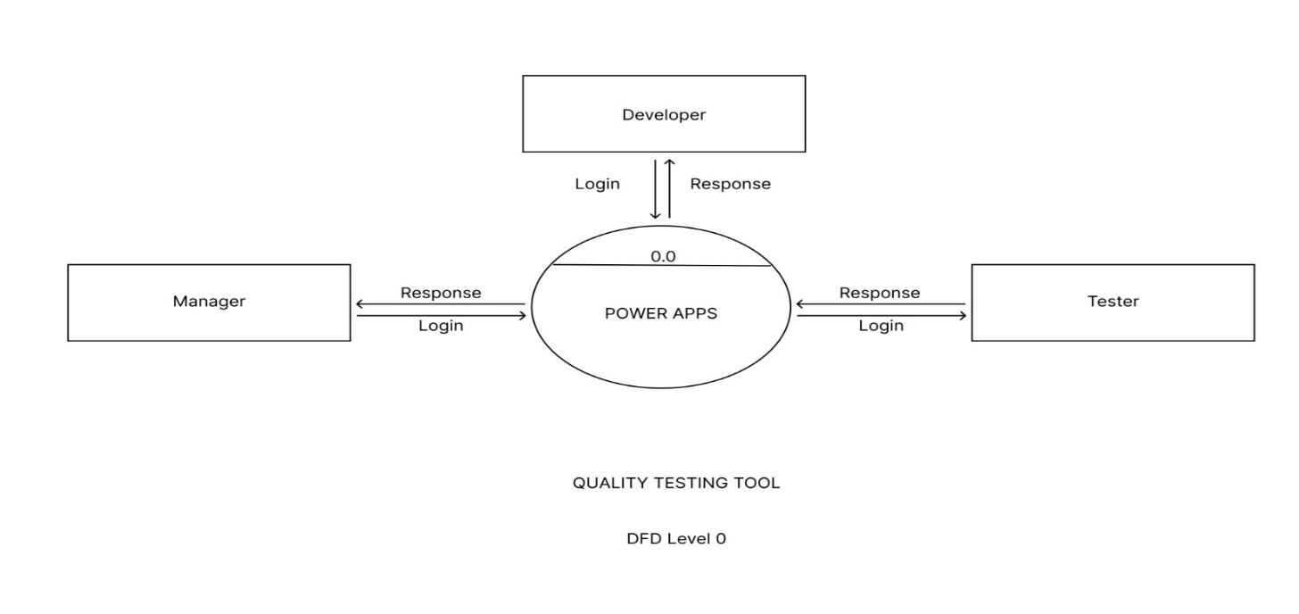

### DFD LEVEL 1

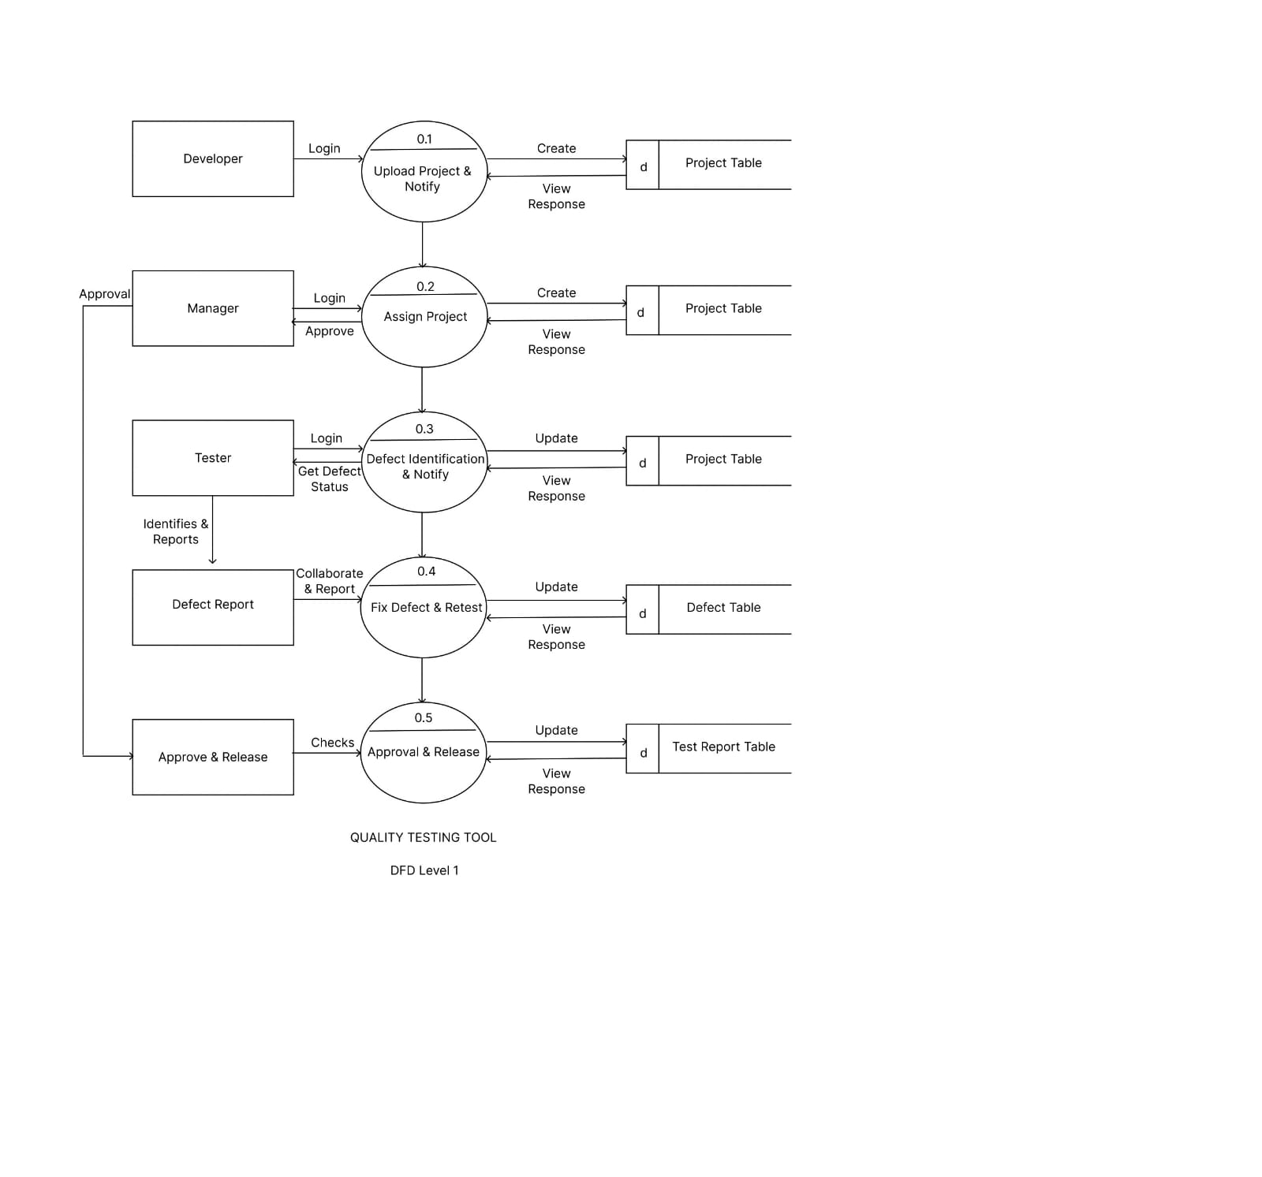

### ER DIAGRAM

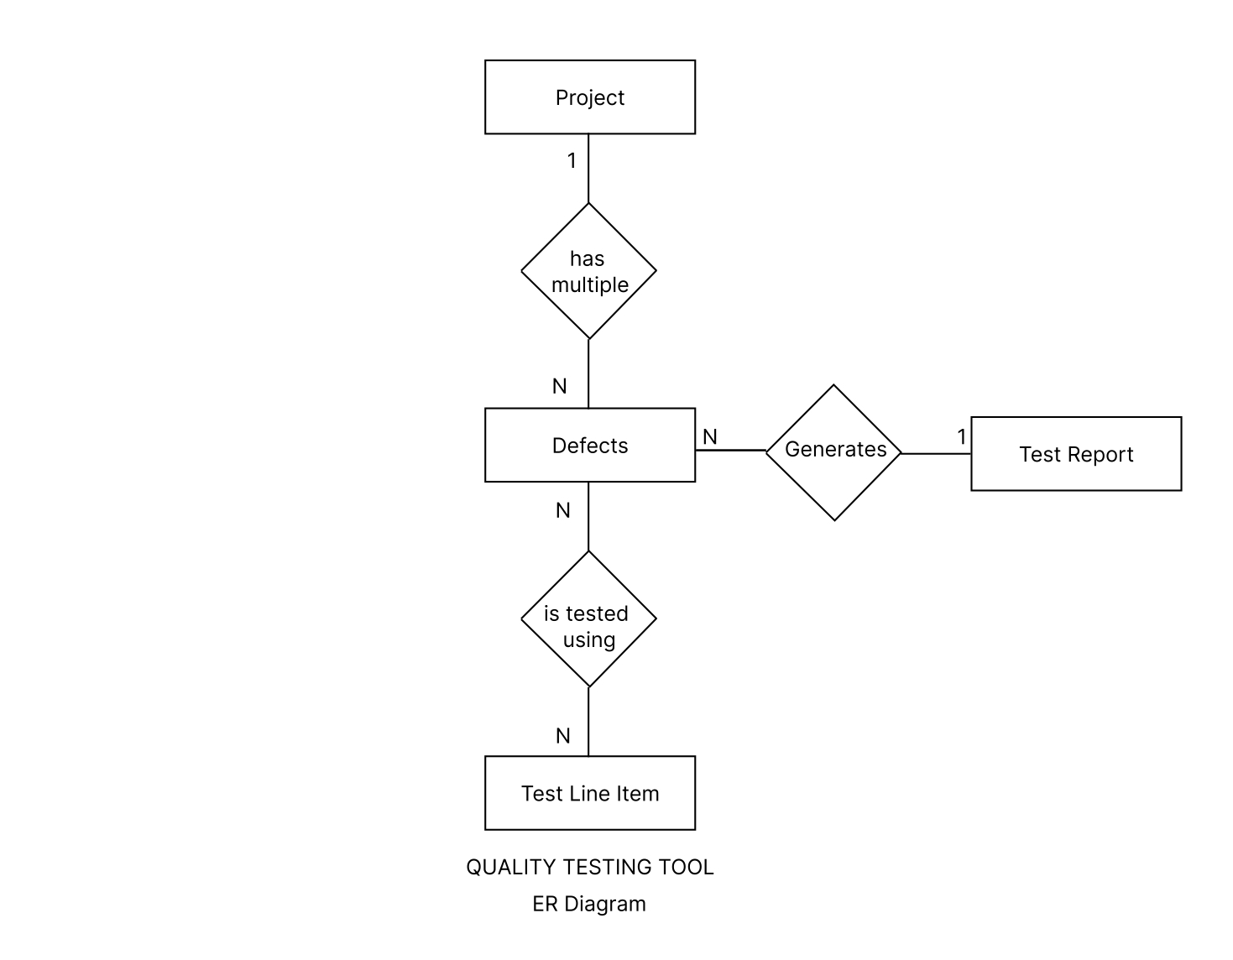

**3.4 UML DIAGRAMS**

### USECASE DIAGRAM

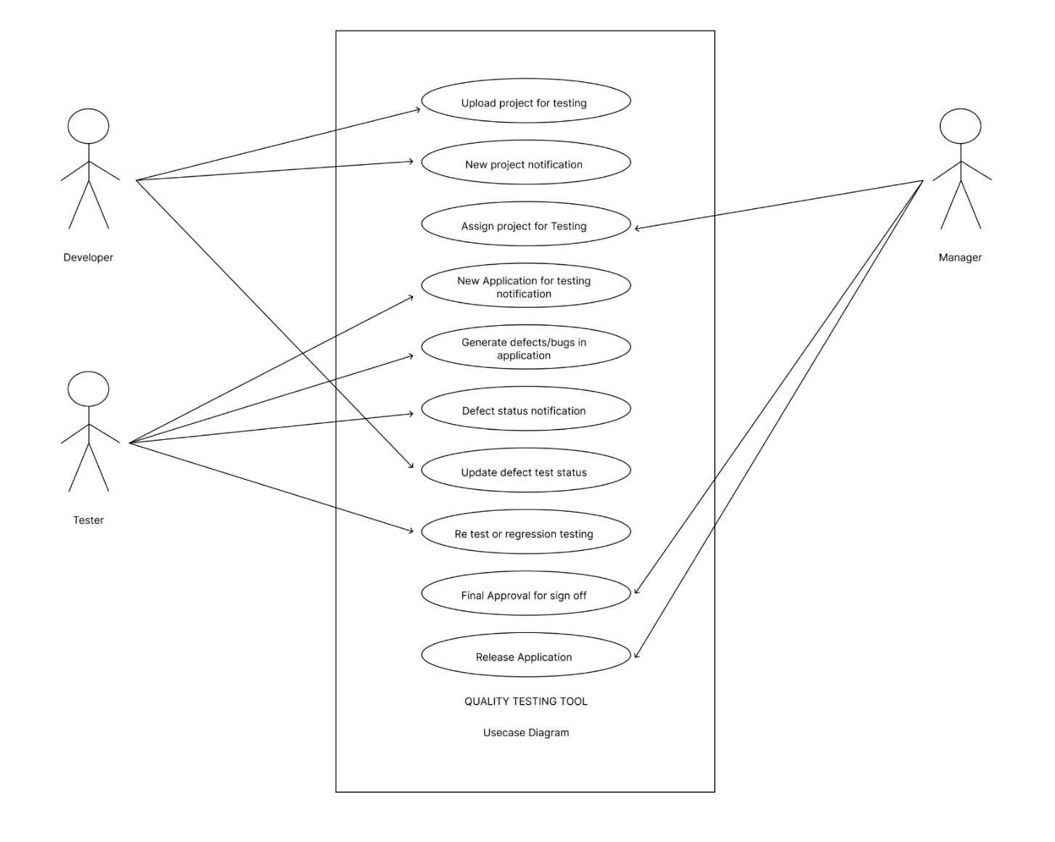

#### 3.5 FEASIBILITY STUDY

The feasibility study is done in advance by Sysfore before taking in the project to check if the project is possible or not. The technical factor is the first factor that is taken into consideration before undertaking the project. Legality is done with the Microsoft team to check if the application is having violating any laws before sending it to the customer. Time is calculated based on the number of hours it will take to complete the project. The time is set by the company to complete the project for the customer. Final decision is taken by the Practice Head of the company to go ahead with the project or not.

Key points of a feasibility study

A feasibility study in project management usually assesses the following areas:

1. **Technical capability:** Does the organization have the technical resources to undertake the project?
2. **Budget:** Does the organization have the financial resources to undertake the project, and is the cost/benefit analysis sufficient to call for moving forward?
3. **Legality:** What are the legal requirements of the project, and can the business meet them?
4. **Risk:** What is the risk associated with undertaking this project? Is the risk worthwhile to the company based on perceived benefits?
5. **Operational feasibility:** Does the project, in its proposed scope, meet the organization’s needs by solving problems and/or taking advantage of identified opportunities?
6. **Time:** Can the project be completed in a reasonable timeline?

## 4. SYSTEM CONFIGURATIONS

### 4.1 HARDWARE REQUIREMENTS

The Hardware requirements are:

**Desktop Application:**

**RAM:** 2GB

**Clock Speed:** 1.5Ghz

**HDD/SSD:** Not Needed since it is cloud application.

**Graphic Card:** Intel HD Graphics/AMD Integrated Graphics

**Mouse and Keyboard:** Any pointing device and 108 keys Keyboard

### 4.2 SOFTWARE REQUIREMENTS

The software requirements for the product are1 For **Desktop Application:**

**OS**: Windows Vista/ Mac OS/ Linux

**Browser**: Any browser with good internet connection

## 5. DETAILS OF SOFTWARE

### 5.1 OVER-VIEW OF FRONT-END POWERAPPS

Power Apps is a suite of apps, services, and connectors, as well as a data platform that supplies a rapid development environment to build custom apps for your business needs. Using Power Apps, you can quickly build custom business apps that connect to your data stored either in the underlying data platform [(Microsoft Dataverse)](https://docs.microsoft.com/en-us/powerapps/maker/data-platform/data-platform-intro) or in various online and on-premises data sources (such as SharePoint, Microsoft 365, Dynamics 365, SQL Server, and so on).

Apps built using Power Apps supply rich business logic and workflow capabilities to transform your manual business operations into digital, automated processes. What is more, apps built using Power Apps have a responsive design and can run seamlessly in browser and on mobile devices (phone or tablet). Power Apps "democratizes" the business-app-building experience by enabling users to create feature-rich, custom business apps without writing code.

Power Apps also provides an extensible platform that lets pro developers programmatically interact with data and metadata, apply business logic, create custom connectors, and integrate with external data.

PowerApps is a tool that allows you to create custom apps, using many of the features of the Office 365 and Microsoft platform. Apps can be accessed via mobile devices or via the browser.

What sets PowerApps apart from other offerings is that while it can be used by developers, it can also be used by non-technical employees A such as business analysts. This means that it is quite fora PowerApps power user to create a custom app. Just like its Microsoft cousin Flow, PowerApps is successfully bringing the [power of process automation to a non-technical audience.](https://www.contentformula.com/blog/how-office-365-and-wizdom-makes-automation-possible-for-everybody/)

Having said that, realistically users will need to have some technical understanding, training and appreciation of the tools and data they are working with. There is a long way to go before everyone is creating their own apps and realistically you may need to bring in developers to work on more complex functionality.

Microsoft defines PowerApps as a suite of apps, services, connectors, and data platform that supplies a rapid application development environment apps for business needs. A While one can add integrations with other applications, a key strength is its ability to build apps based on Office 365 and Microsoft Dynamics 365. If in a particular process that uses various parts of A the Microsoft universe, for example SharePoint Online, Excel and Dynamics 365, then an app based on PowerApps has the potential to bring them all together for users in one handy, convenient experience.

The beauty of building one’s own app is that one can also make sure it is completely wrapped around the organization’s unique user needs and the way one’s employees work. Using Power Apps, one can create three types of apps: **canvas**, **model-driven**, and **portal**. More information

To create an app, start with [make.powerapps.com.](https://make.powerapps.com/)

* **Power Apps Studio** is the app designer used for building canvas apps. The app designer makes creating apps feel more like building a slide deck in Microsoft PowerPoint.
* **App designer** for model-driven apps lets you define the sitemap and add components to build a model-driven app.
* **Power Apps portals Studio** is a WYSIWYG design tool to add and configure webpages, components, forms, and lists.

### Canvas App

Canvas app in PowerApps helps developers to design and build apps as per the project scope. Microsoft canvas supplies a comfortable environment to help developers create what they need.

Rather than using any programming tool or coding the app, the Canvas design app allows developers to drag and drop elements in Canvas and build an app. Throughout app development, developers can format the right conditions and settings needed to make an app work.

If you are using existing data sources, you can create apps that integrate directly with the sources without any issues. All this can be done by using Microsoft third-party sources that are highly compatible.

Developing over 200 unique data integration sources including Dynamic 365, Office 365, SQL, CDS, and SharePoint, one can create fully customized apps that can be shared amongst any organization members.

**Model-Driven App**

If the app needs complex business logic, you need to build a “model app.” These apps can run either as a standalone app or as a backend to the canvas app. One of the major benefits of Model-driven apps is to generate data models that allow data input and defines a structure that confirms your information. No matter whatever the source may be, the app conforms to your data and not the other way around. Similarly, whenever you build an app, having a consistent business process can be a crucial deciding factor. These various steps that make up an entire process can prove to be fatal for the app’s successful creation.

Once everything is done, one can use your app designer to build a final product. No matter whether the app is easy or complex, what matters is the steps followed till completion. The simple app architecture allows to tailor the app, without creating a new code.

**5.2 OVERVIEW OF BACK-END**

#### Microsoft Dataverse

Dataverse lets you securely store and manage data that is used by business applications. Data within Dataverse is stored within a set of tables. A table is a set of rows (formerly referred to as records) and columns (formerly referred to as fields/attributes). Each column in the table is designed to store a certain type of data, for example, name, age, salary, and so on. Dataverse includes a base set of standard tables that cover typical scenarios, but you can also create custom tables specific to your organization and populate them with data by using Power Query. App makers can then use Power Apps to build rich applications that use this data.

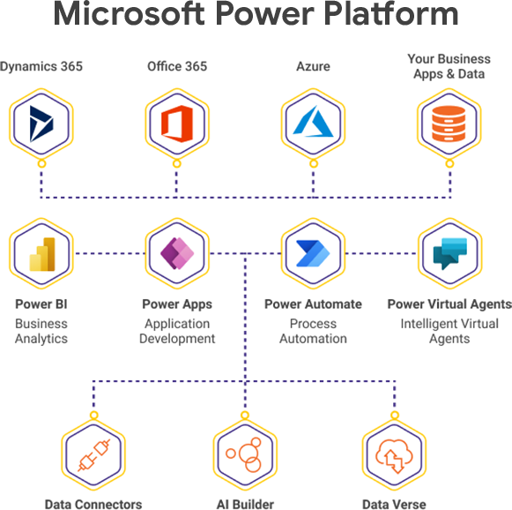

Standard and custom tables within Dataverse supply a secure and cloud-based storage choice for your data. Tables let you create a business-focused definition of your organization's data for use within apps. If you are not sure whether tables are your best option, consider these benefits:

* **Easy to manage** – Both the metadata and data are stored in the cloud. You do not need to worry about the details of how they are stored.
* **Easy to secure** – Data is securely stored so that users can see it only if you grant them access. Role-based security allows you to control access to tables for different users within your organization.
* **Access your Dynamics 365 Data** – Data from your Dynamics 365 applications is also stored within Dataverse, allowing you to quickly build apps that use your Dynamics 365 data and extend your apps with Power Apps.
* **Rich metadata** – Data types and relationships are used directly within Power Apps.
* **Logic and validation** – Define calculated columns, business rules, workflows, and business process flow to ensure data quality and drive business processes.
* **Productivity tools** – Tables are available within the add-ins for Microsoft Excel to increase productivity and ensure data accessibility.

#### SharePoint

Windows SharePoint Services function the basic functionality that Gartner calls Basic Content Services. It offers the user access to Versioning and Check-in/Checkout functionality. WSS can then be extended with the applets to add added collaborative functions like email alerts, shared calendars, etc.

Microsoft Office SharePoint Server (MOSS) sits on top of WSS and adds added features, both to the underlying WSS layer, as well as added ways for the end-user to interact with the repository. The data lives in a SQL Database. Using Webparts it can then present this information to the user using a wide range of different modules and for interaction in different business scenarios. These include such diverse applications as Collaboration, Document management, Records Management (including DOD 5015.2 certified components), Workflow, Personalization, more complex metadata models as well as Blogs and Wikis from the Web 2.0 side.

Finally, there is the Microsoft Search Server, an Enterprise Search engine that supplies advanced indexing and searching capabilities that can be integrated into a MOSS Web-based interface.

Microsoft itself describes SharePoint as Collaboration, Portal, Search, [Enterprise Content Management (ECM), B](https://info.aiim.org/what-is-ecm?hsLang=en)usiness Process Management (BPM), and Business intelligence (BI), so again a lot to choose from.

Research by AIIM has shown that even today, many people [start their large information management projects w](https://info.aiim.org/aiim-blog/implementing-information-management-on-sharepoint-and-office365?hsLang=en)ithout a clear plan, or without a plan altogether, or steadfastly ignoring the one that you have. For a product that has so many sides as a SharePoint installation can potentially have, it is a choice that needs to be made before you jump in.

**5.3 ABOUT THE PLATFORM**

### Microsoft Power Apps

Power Apps is a suite of apps, services, and connectors, as well as a data platform, that supplies a rapid development environment to build custom apps for your business needs. Using Power Apps, you can quickly build custom business apps that connect to your data stored either in the underlying data platform (Microsoft Dataverse) or in various online and on-premises data sources (such as SharePoint, Microsoft 365, Dynamics 365, SQL Server, and so on).

Apps built using Power Apps supply rich business logic and workflow capabilities to transform your manual business operations into digital, automated processes. What is more, apps built using Power Apps have a responsive design and can run seamlessly in browser and on mobile devices (phone or tablet). Power Apps "democratizes" the business-app-building experience by enabling users to create feature- rich, custom business apps without writing code.

Power Apps also provides an extensible platform that lets pro developers programmatically interact with data and metadata, apply business logic, create custom connectors, and integrate with external data.

Dynamics 365 apps (such as Dynamics 365 Sales, Dynamics 365 Customer Service, and Dynamics 365 Marketing) also use the underlying Dataverse platform used by Power Apps to store and secure data. This enables you to build apps using Power Apps and Dataverse directly against your core business data already used within Dynamics 365, without the need for integration.

Developers are app makers who can write code to extend business app creation and customization. Developers can use code to create data and metadata, apply server-side logic using Azure functions, plug-ins, and workflow extensions, apply client-side logic using JavaScript, integrate with external data using virtual entities and webhooks, build custom connectors, and embed apps into your website experiences to create integrated solutions.

#### Microsoft Power Platform



# Power BI

Discover actionable insights from data across the organization. Share insights through data visualizations. Make reports and dashboards that enable you to make informed decisions quickly. Display data that makes sense to users. Built-in governance and security allowing businesses to focus on using data.



# Power Apps

A low code development environment that enables users to build custom business apps. Build apps in hours that easily connect to data. Create web and mobile applications that run on all devices. A simple user interface to develop apps whether you are a business user or a pro-developer.

# Power Automate

Create automated workflows between applications and services. Automate repetitive business processes such as communication, data collections, and decision approvals. A simple user interface allows every level of user to automate work tasks. Create enterprise-grade process automation.

# Power Virtual Agents

Create powerful chatbots using a guided, no-code graphical interface without the help of data scientists or developers. Minimize the IT effort needed to deploy and keep a custom solution. Out-of-the- box integration with Power Automate and its ecosystems of hundreds of connectors.

## 6.SYSTEM DESIGN

### 6.1 ARCHITECTURAL DESIGN

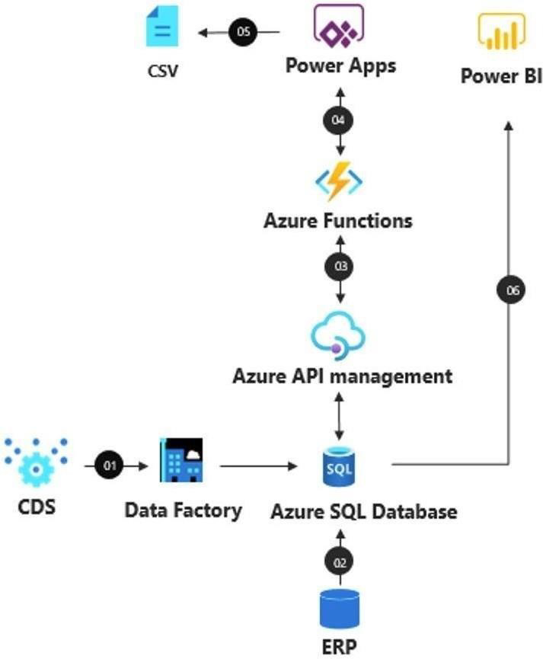

**6.2 INPUT/OUTPUT DESIGN**

**Desktop Application**

### Quality Testing Tool

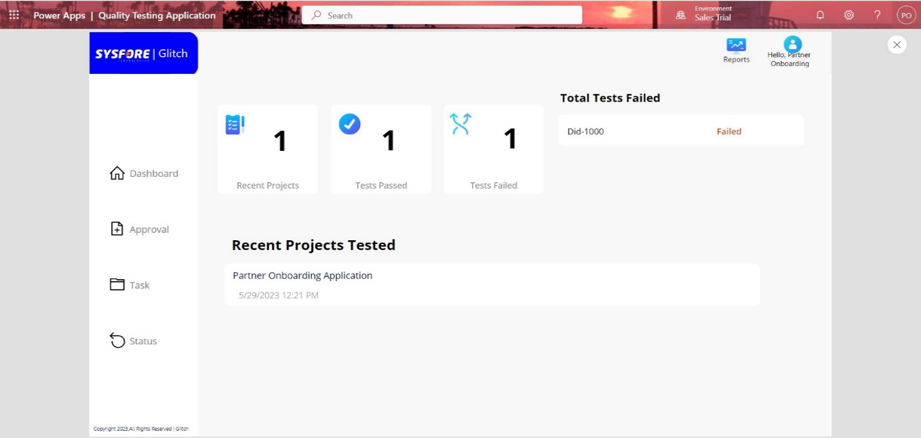

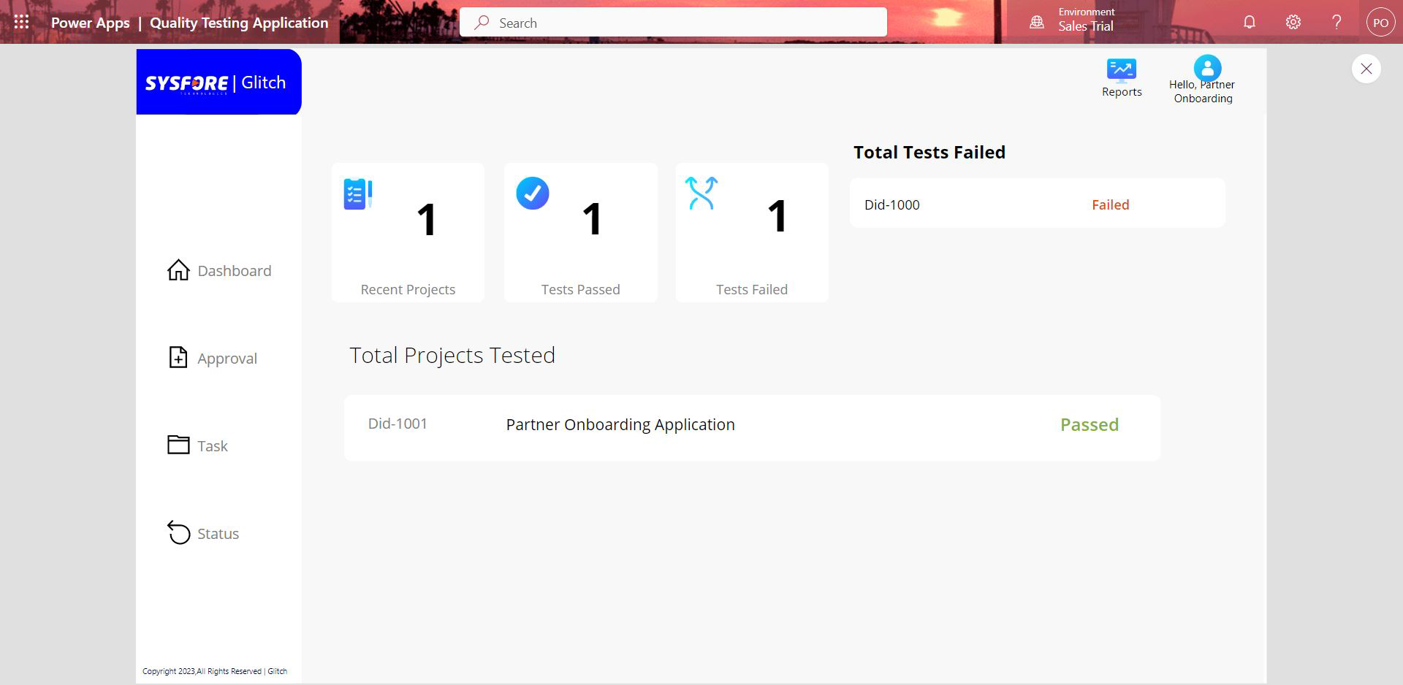

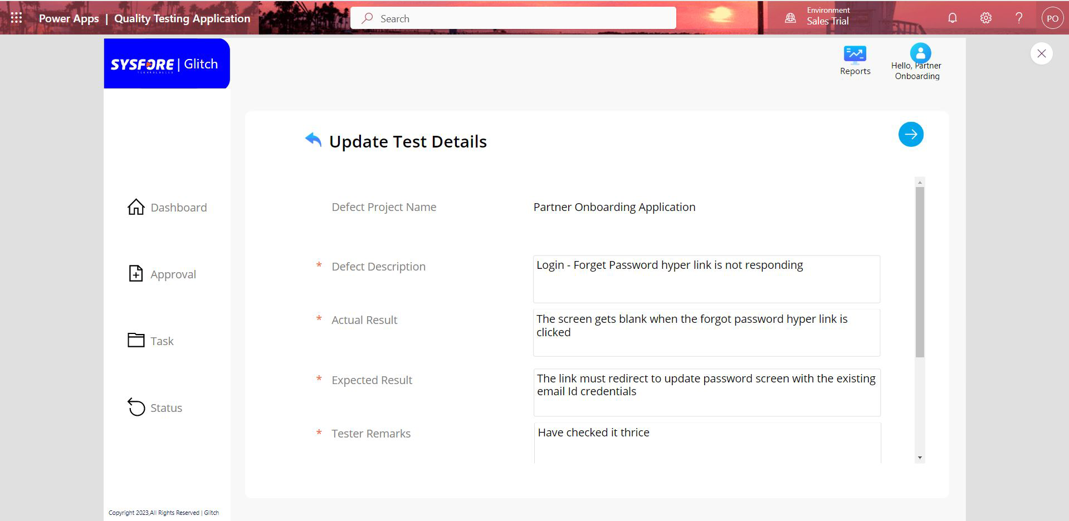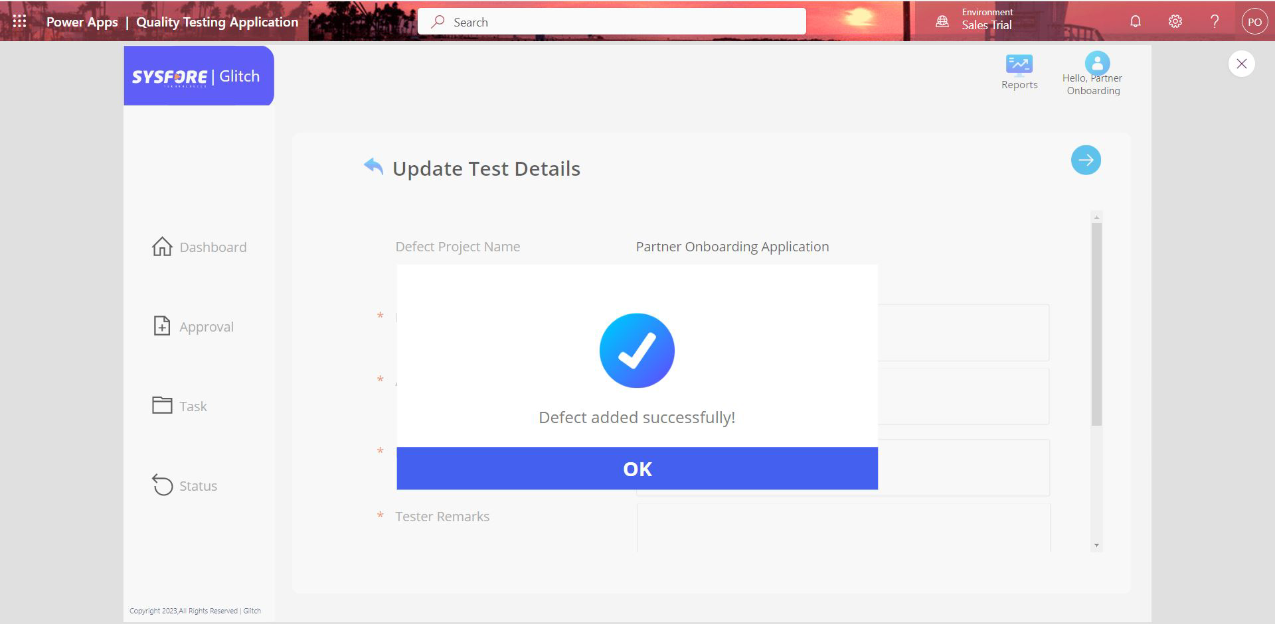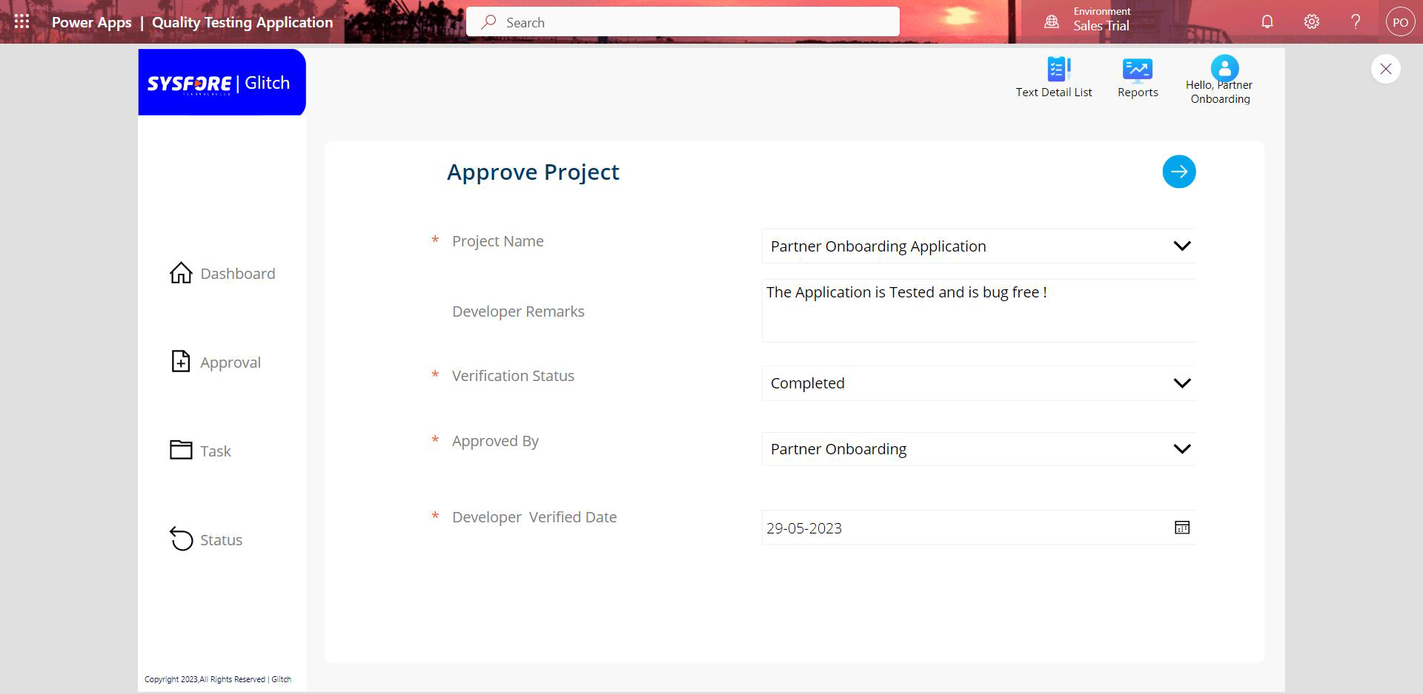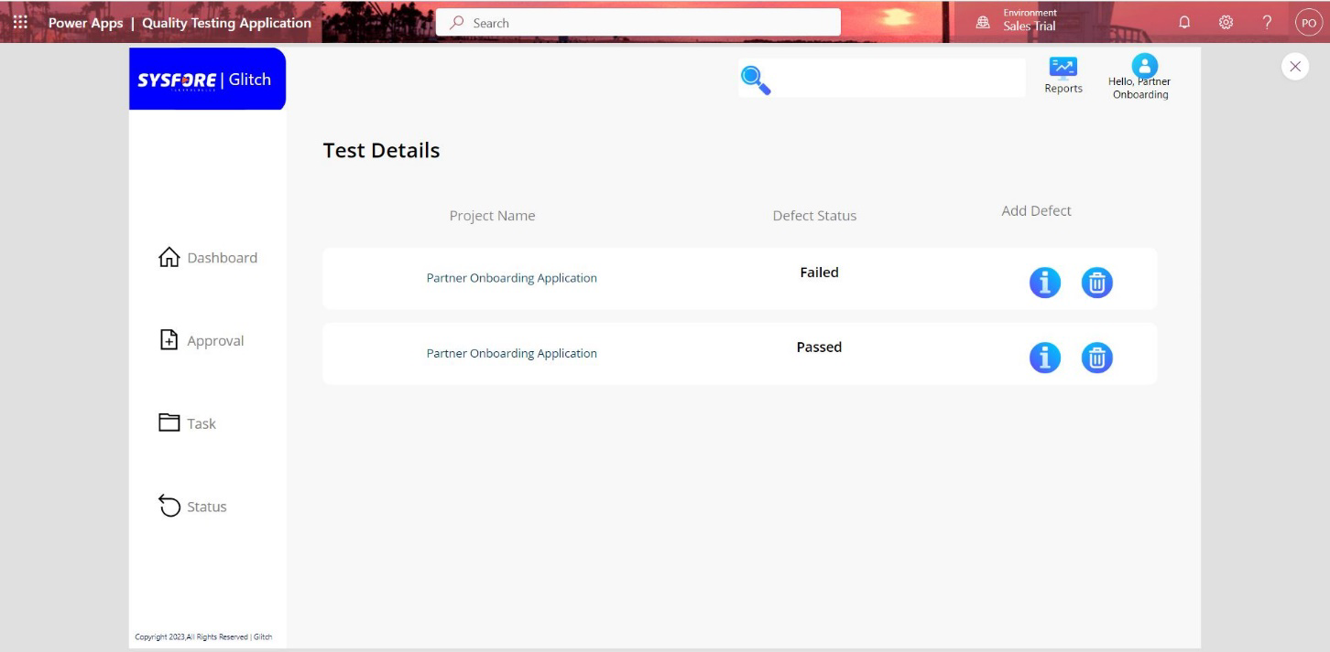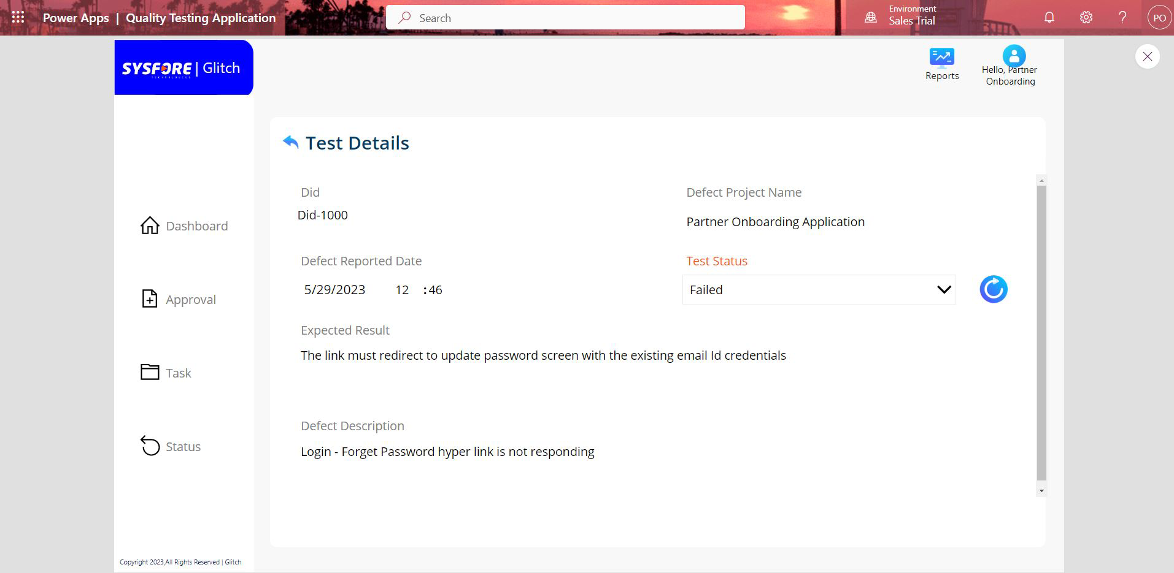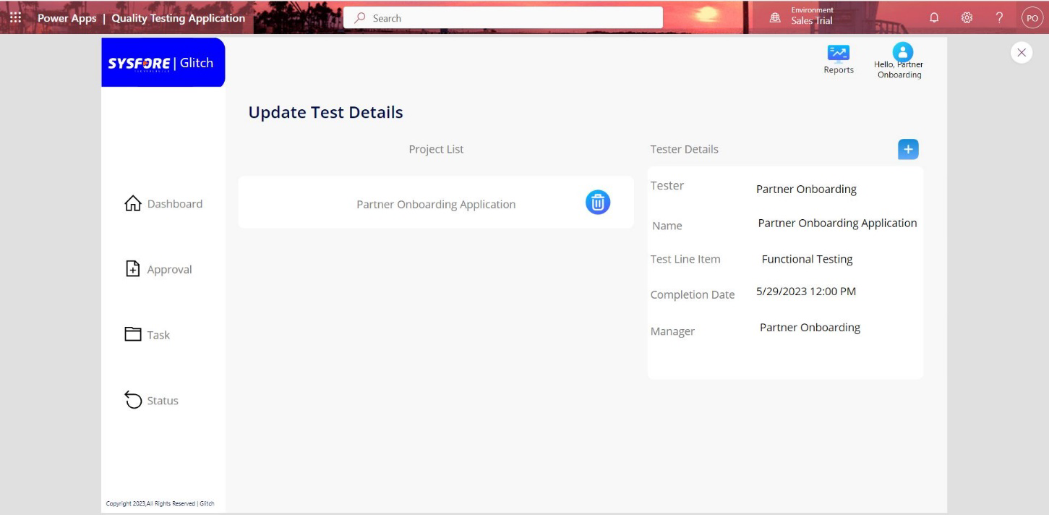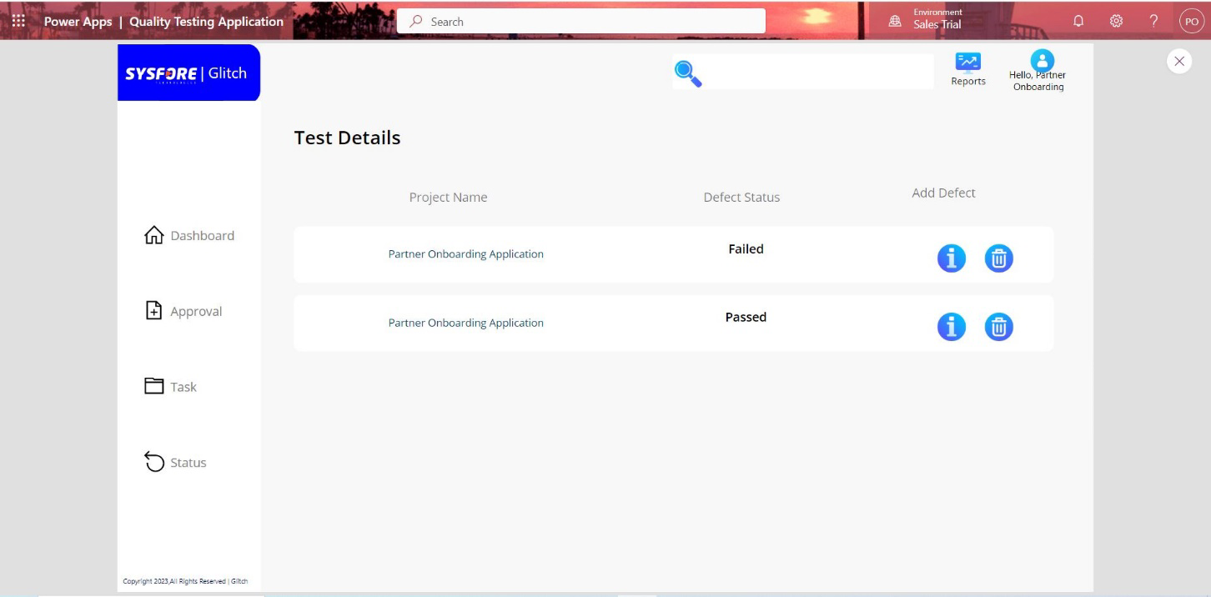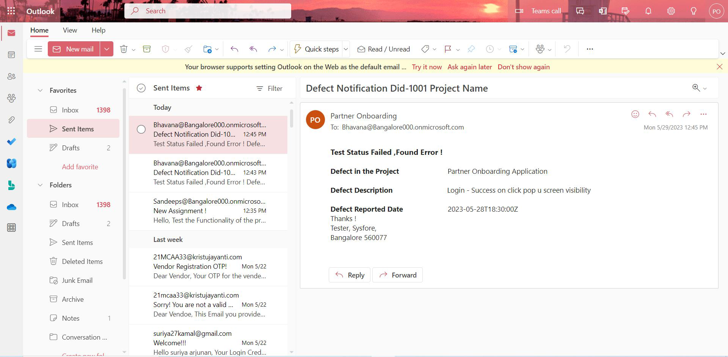

### Quality Testing Tool (Manager)

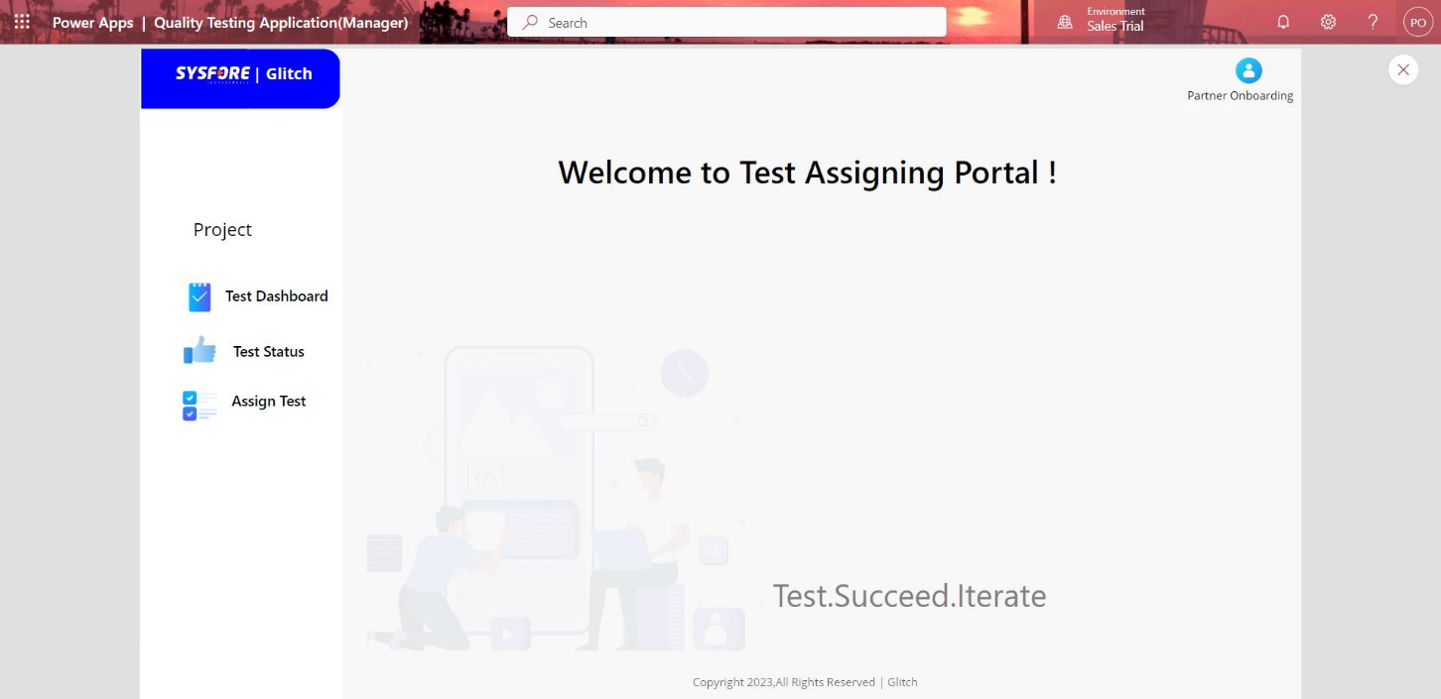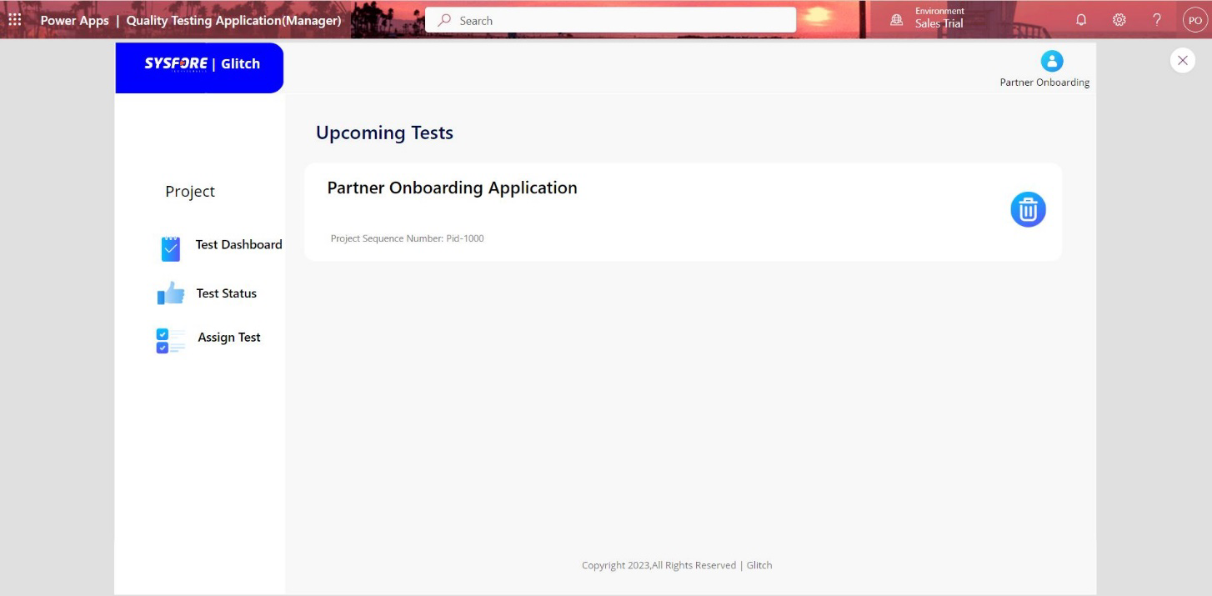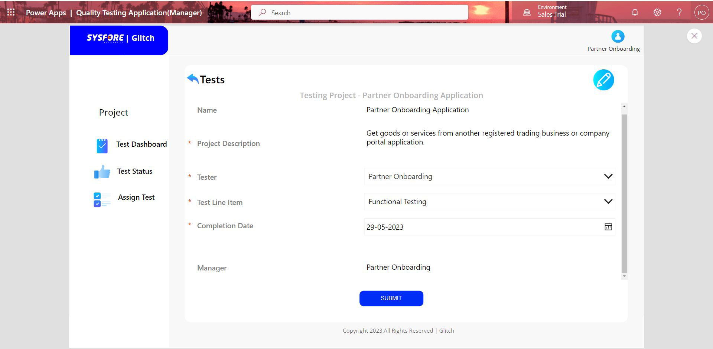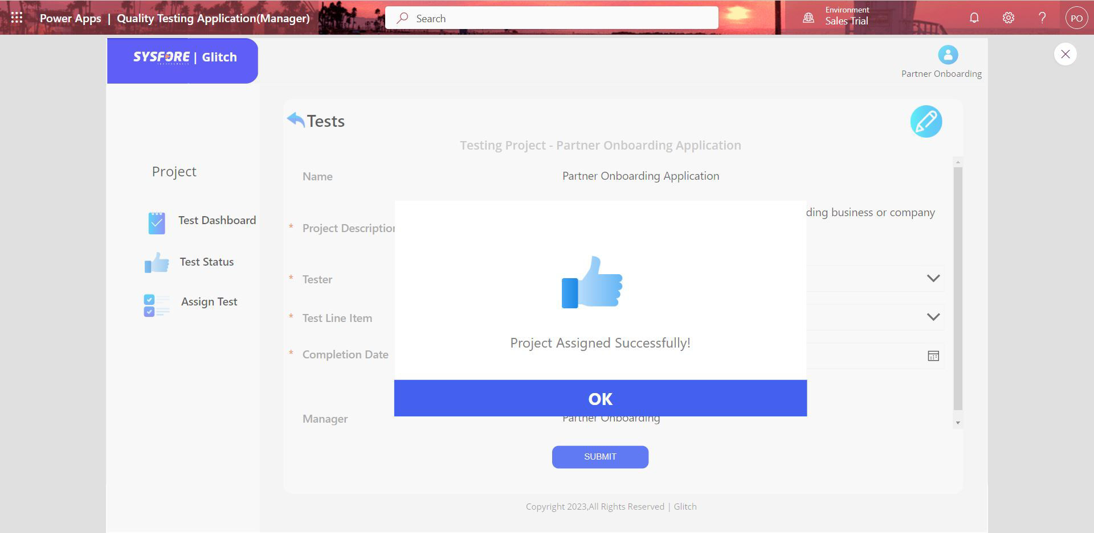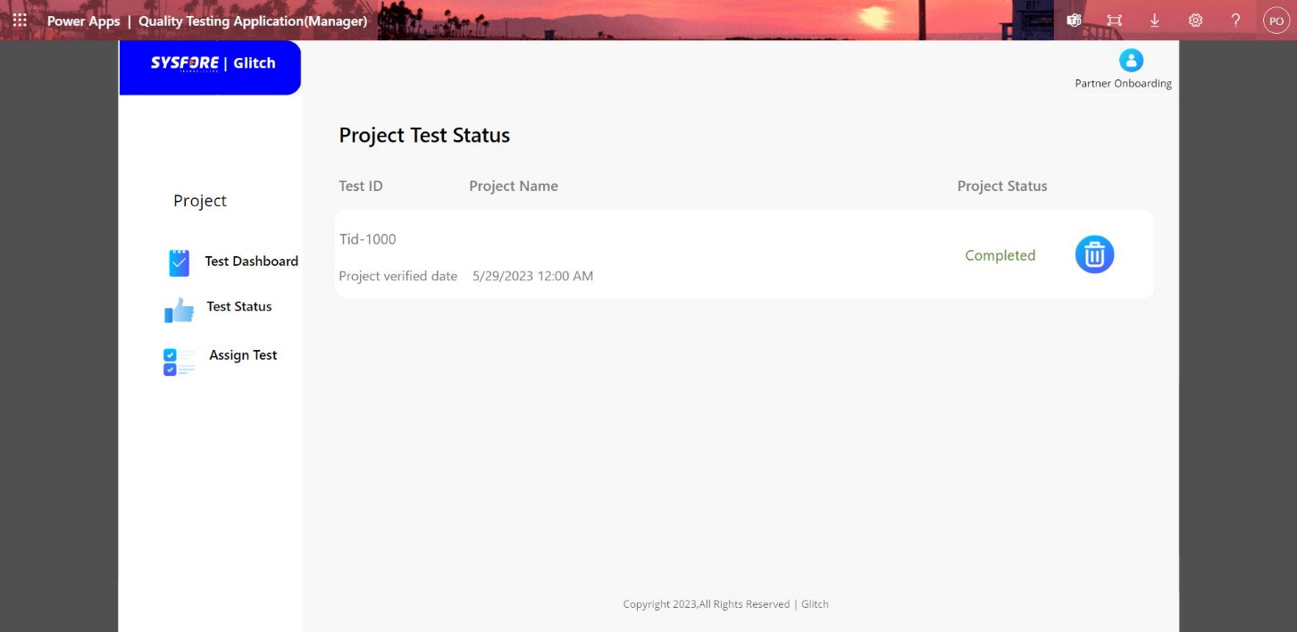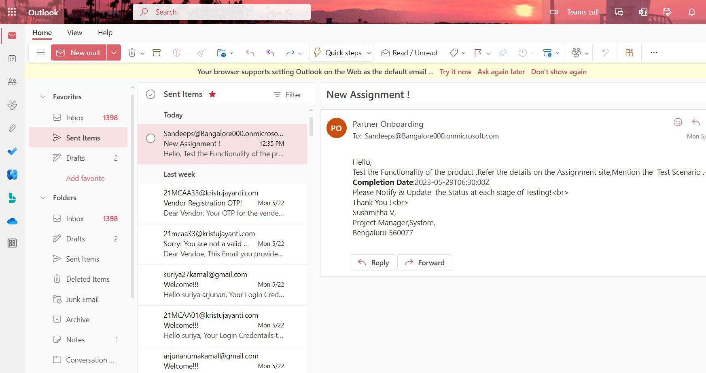

## 7. TESTING

Testing is the process of running software and looking for flaws. Our program must be error-free to work effectively. If the testing is completed successfully, the program will be free of any faults.

**Unit tests**

Unit tests are extremely low level and close to the source of an application. They consist in testing individual methods and functions of the classes, components, or modules used by your software. Unit tests are quite cheap to automate and can run very quickly by a continuous integration server.

**Integration tests**

Integration tests verify that different modules or services used by your application work well together. For example, it can be evaluating the interaction with the database or making sure that microservices work together as expected. These types of tests are more expensive to run as they require multiple parts of the application to be up and running.

### Functional tests

Functional tests focus on the business requirements of an application. They only verify the output of an action and do not check the intermediate states of the system when performing that action.

### Smoke testing

Smoke tests are basic tests that check the basic functionality of an application. They are meant to be quick to execute, and their goal is to give you the assurance that the major features of your system are working as expected.

Smoke tests can be useful right after a new build is made to decide whether you can run more expensive tests, or right after a deployment to make sure that they application is running properly in the newly deployed environment.

### Performance testing

Performance tests evaluate how a system performs under a particular workload. These tests help to measure the reliability, speed, scalability, and responsiveness of an application. For instance, a performance test can see response times when executing a high number of requests or decide how system behaves with a significant amount of data. It can decide if an application meet performance requirements, find bottlenecks, measure stability during peak traffic, and more.

## 8. IMPLEMENTATION

**(Note: Due to the privacy policies in the Company profile could not supply any implementation details)**

In the quality testing tool described, there are three primary user roles: Manager, Tester, and Developer. Here is a detailed description of each user role and their responsibilities within the application:

**1. Manager:**

The Manager plays a crucial role in overseeing the testing process and ensuring the quality of the delivered application.

Responsibilities:

* Assign Projects: The Manager has the authority to assign specific projects to the testing team using the tool. They can distribute resources and ensure proper testing coverage for each project.
* Monitor Progress: The Manager can track the progress of ongoing testing activities, review test reports, and assess the overall quality of the application.
* Supply Guidance: The Manager may supply guidance and instructions to the testing team, addressing any questions or concerns they may have during the testing process.
* Approve Bug Reports: The Manager can review and approve bug reports generated by the testing team before they are shared with the development team.

**2. Tester:**

Tester's handle executing test cases, finding, and reporting bugs, and ensuring the overall quality of the application.

Responsibilities:

* Access Projects: Testers can access the projects assigned to them by the Manager. They can view the application, perform various tests, and report bugs using the tool.
* Execute Test Cases: Testers execute predefined test cases to assess the functionality, performance, and usability of the application.
* Report Bugs: When Testers encounter bugs or issues during testing, they can report them using the quality testing tool. They supply detailed information about each bug, including steps to reproduce, screenshots, and related data.
* Collaborate with Developers: Testers may collaborate with developers to supply more information or clarification on reported bugs and aid in resolving issues.

**3. Developer:**

Developers handle analysing reported bugs, addressing the identified issues, and delivering bug-free software.

Responsibilities:

* Access Bug Reports: Developers can access the bug reports sent by Testers through the quality testing tool.
* Analyse and Reproduce Bugs: Developers review each bug report, reproduce the reported issues, and analyse the root cause.
* Resolve Bugs: Based on the analysis, Developers work on resolving the identified bugs, implementing fixes, and conducting necessary testing to ensure bug-free software.
* Communicate Progress: Developers may supply updates to Testers and the Manager about the status of bug fixes, any challenges faced, and estimated times for resolution.
* Validate Fixes: Once the bug fixes are implemented, Developers collaborate with Testers to verify the fixes and ensure that the reported issues have been successfully resolved.

By dividing the responsibilities among these user roles, the quality testing tool aims to improve the efficiency and effectiveness of bug reporting, testing, and collaboration within the application development process.

## 9. CONCLUSION AND FUTURE ENHANCEMENTS

**CONCLUSION:**

The development of the quality testing tool aims to address the challenges faced by the Application Testing Team in manual bug reporting in sysfore organisation and improve the overall quality of the delivered application. By supplying an efficient and streamlined process for bug reporting, the tool enhances the team's capabilities and reduces the risk of product quality decline during customer demonstrations or user deployment. The tool's focus areas include project assignment, project upload, and detailed test report generation, supplying valuable insights for effective issue resolution.

**FUTURE ENHANCEMENTS:**

While the current scope of the quality testing tool focuses on manual bug reporting, there are several potential future enhancements to consider:

* Integration with Automated Testing Tools: Consider integrating the quality testing tool with automated testing tools, such as continuous integration servers or test automation frameworks. This integration would enable seamless collaboration between manual and automated testing, supplying a comprehensive testing solution.
* Test Case Management: Extend the tool to include test case management capabilities, allowing Testers to create, organize, and execute test cases within the application. This enhancement would enhance the efficiency and effectiveness of the testing process.
* Collaboration and Notification Features: Implement collaboration features within the tool, enabling seamless communication and collaboration between Testers, Developers, and Managers. Incorporate notification mechanisms to alert relevant stakeholders about bug reports, status updates, and resolution progress.
* Integration with Project Management Tools: Explore integration with project management tools, enabling synchronization of project details, timelines, and resources. This enhancement would ensure better coordination between project management and testing activities.
* Advanced Reporting and Analytics: Enhance the reporting capabilities of the tool by incorporating advanced analytics features. Supply visual representations of test results, bug trends, and overall quality metrics to enable data-driven decision-making.
* Expand Platform Support: Initially, focus on supporting a specific platform or technology stack. However, consider expanding the tool's compatibility to cover a broader range of platforms, such as web, mobile, or desktop applications, to cater to diverse testing requirements.

By considering these future enhancements, the quality testing tool can evolve into a comprehensive solution that addresses not only manual bug reporting but also incorporates automated testing, advanced reporting, collaboration, and integration capabilities, further improving the testing process and overall application quality.

## 10. BIBLIOGRAPHY

<https://docs.microsoft.com/en-us/learn/paths/power-plat-fundamentals/><https://docs.microsoft.com/en-us/power-apps/maker/canvas-apps/><https://docs.microsoft.com/en-us/power-apps/maker/model-driven-apps/app-building-steps><https://docs.microsoft.com/en-us/power-apps/maker/model-driven-apps/model-driven-app-overview><https://docs.microsoft.com/en-us/power-apps/maker/data-platform/create-edit-entities-portal>

## 11. APPENDICES A – Table Structure

### TABLE STRUCTURE

### Project Table

| **Table Type** | **Table name** | **Column** | **Datatype** | **Required/Optional** |
| --- | --- | --- | --- | --- |
| **Transaction** | **Project** | **Table Description** | **NA** | **N/A** |
| Transaction | Project | Project ID | Auto number | Required |
| Transaction | Project | Project Name | Text | Required |
| Transaction | Project | Project Type | Choice | Required |
| Transaction | Project | Upload Project | File | Optional |
| Transaction | Project | Project Description | Text area | Required |
| Transaction | Project | Emp ID | Lookup | Required |

#### Test Report

| **Table Type** | **Table Name** | **Column** | **Data Type** | **Required/Optional** |
| --- | --- | --- | --- | --- |
| Transaction | Test Report | Tester ID | Auto number | Required |
| Transaction | Test Report | Test case Name | Lookup | Required |
| Transaction | Test Report | Module | Text | Optional |
| Transaction | Test Report | Add Image/Video | File | Required |
| Transaction | Test Report | Test Status | Choice | Required |
| Transaction | Test Report | Test Remarks | Multiline Text | Required |
| Transaction | Test Report | Test Start Date & Time | Date & time | Required |
| Transaction | Test Report | Test End Date & Time | Date & time | Required |
| Transaction | Test Report | Actual Result | Text area | Required |
| Transaction | Test Report | Test Completion Date | Date & time | Required |
| Transaction | Test Report | Assigned By | Lookup | Required |
| Transaction | Test Report | Expected Result | Text area | Required |

#### Defect Table

| **Table Type** | **Table Name** | **Column** | **Data Type** | **Required/Optional** |
| --- | --- | --- | --- | --- |
| Transaction | Defect | Tester Id | Lookup | Required |
| Transaction | Defect | Defect Id | Auto number | Required |
| Transaction | Defect | Defect Name | Single line of text | Required |
| Transaction | Defect | Defect Description | Text area | Required |
| Transaction | Defect | Defect Status | choice | Required |

#### User Table

| **Table Type** | **Table name** | **Column** | **Datatype** | **Required/Optional** |
| --- | --- | --- | --- | --- |
| Master | User | Emp ID | Auto Number | Required |
| Master | User | Name | Text | Required |
| Master | User | Designation | Text | Required |

#### Testcase Line Item

| **Table Type** | **Table name** | **Column** | **Datatype** | **Required/Optional** |
| --- | --- | --- | --- | --- |
| Master | Testcase Line Item | Test Id | Auto number | Required |
| Master | Testcase Line Item | Project Id | Look up | Required |
| Master | Testcase Line Item | Test case name | Text | Required |

## 12.APPENDICES B-SCREEN SHOTS

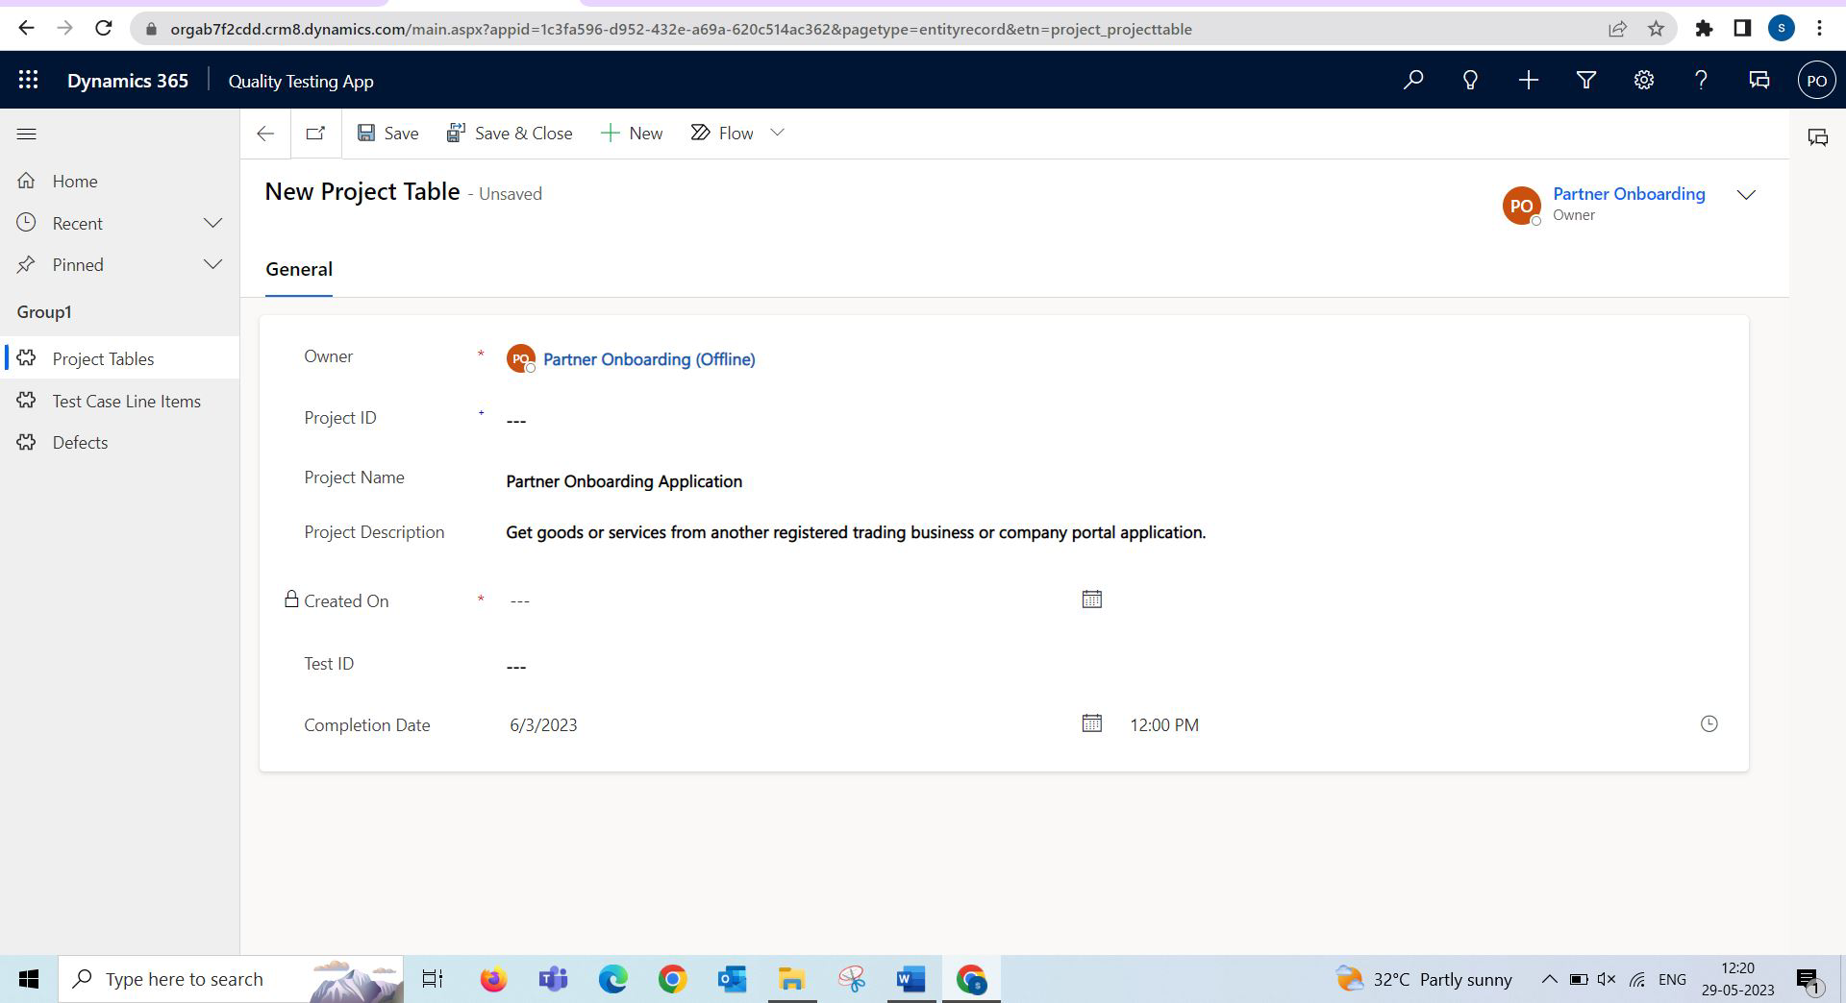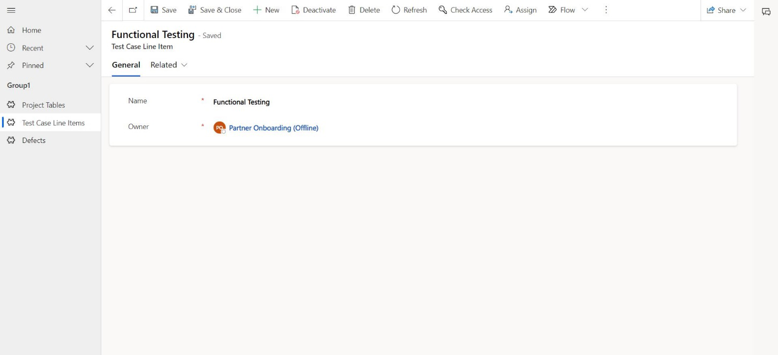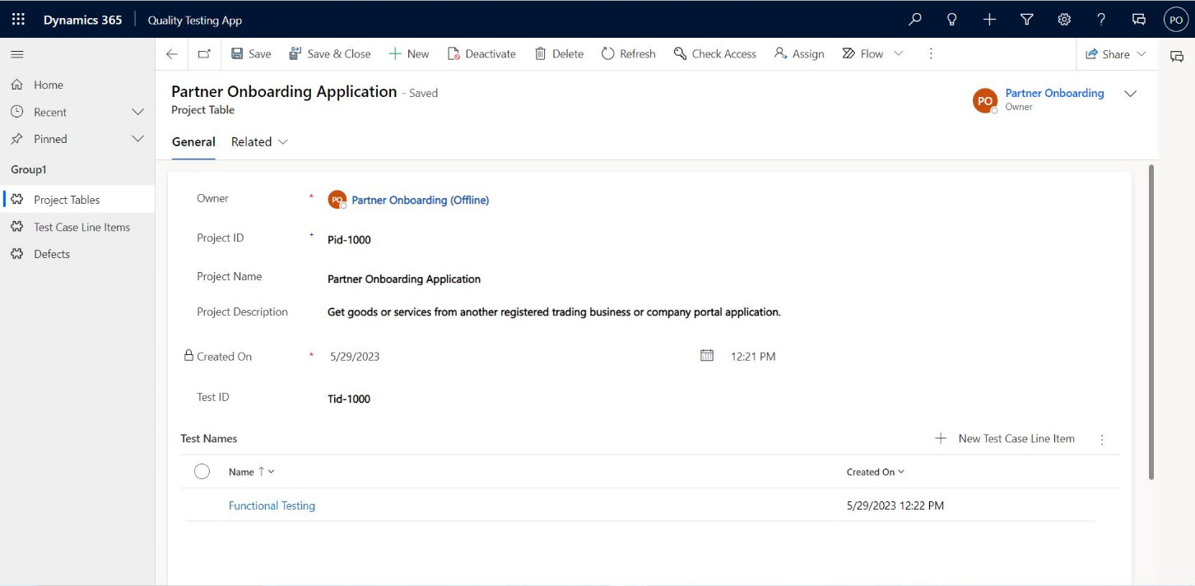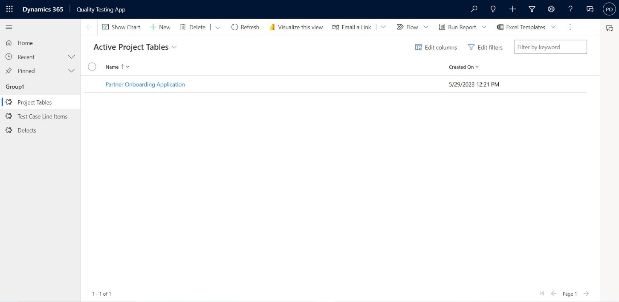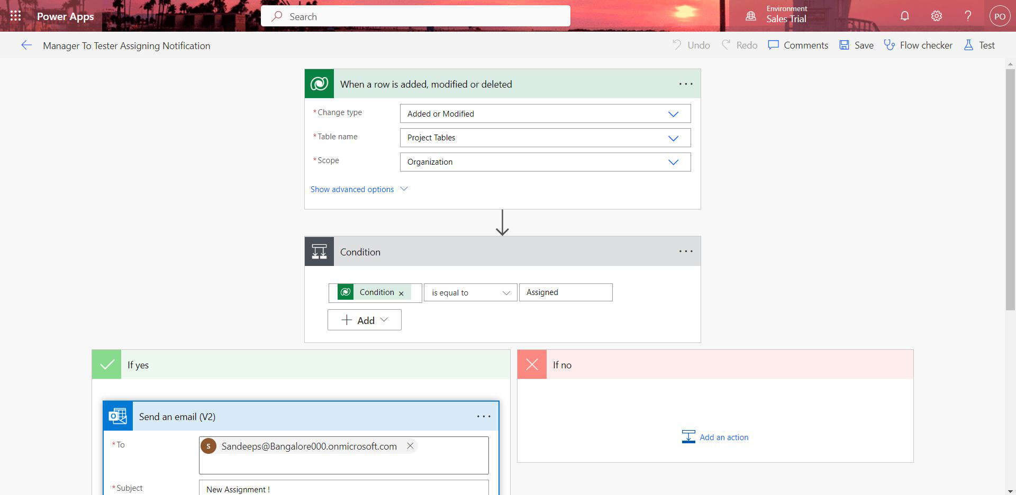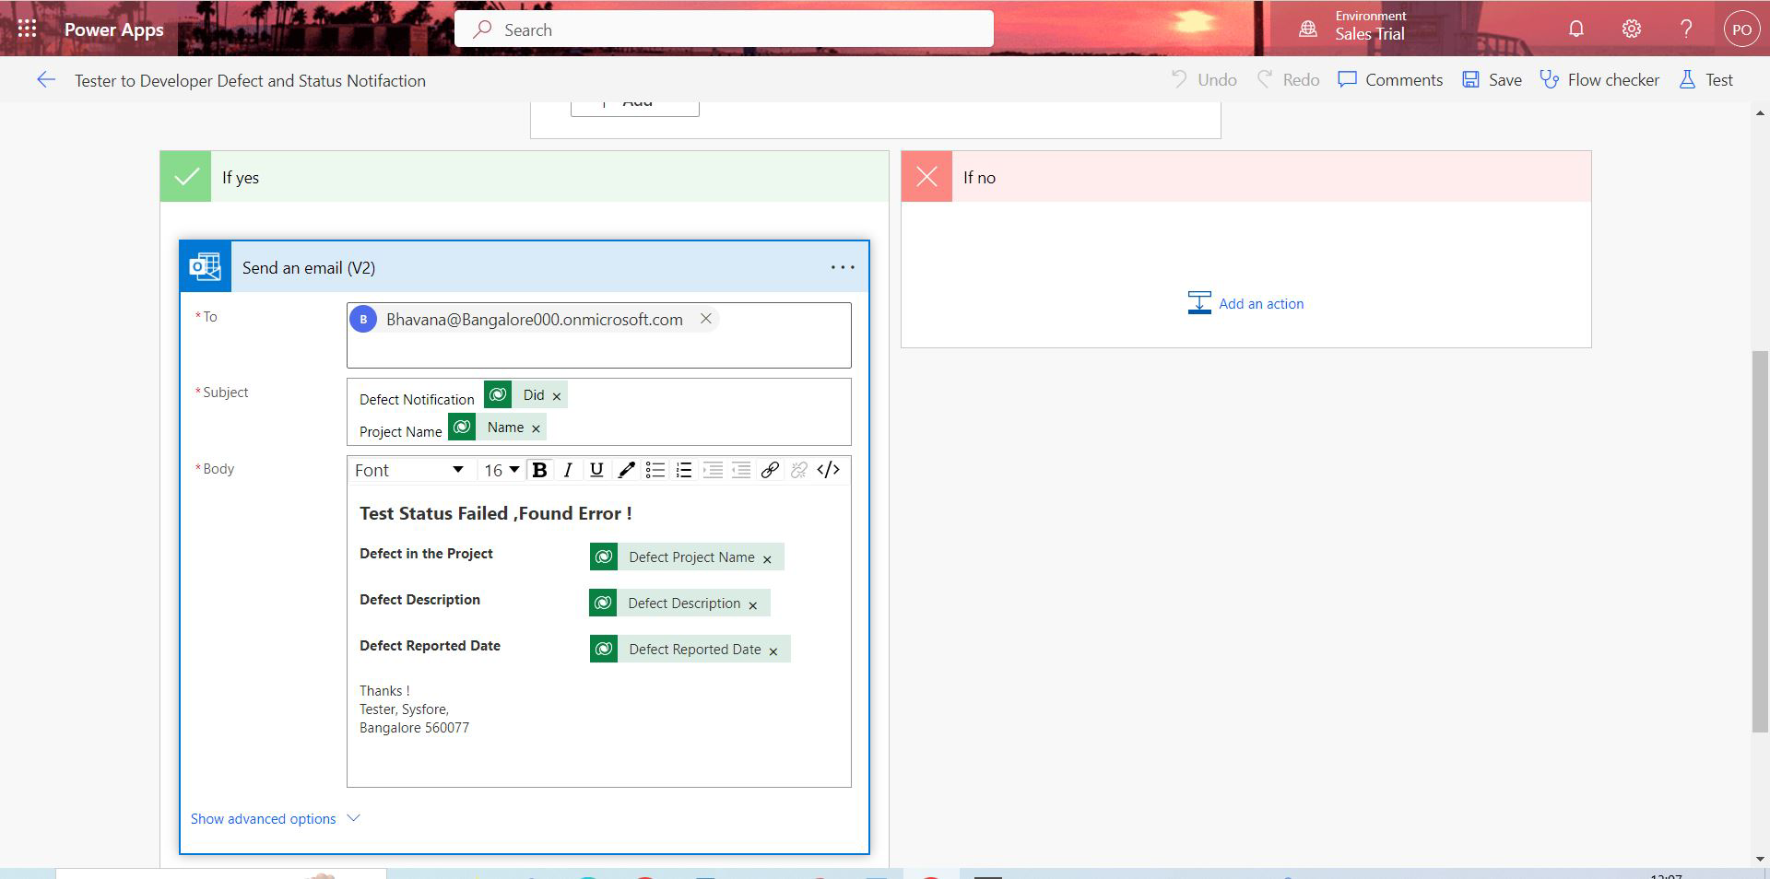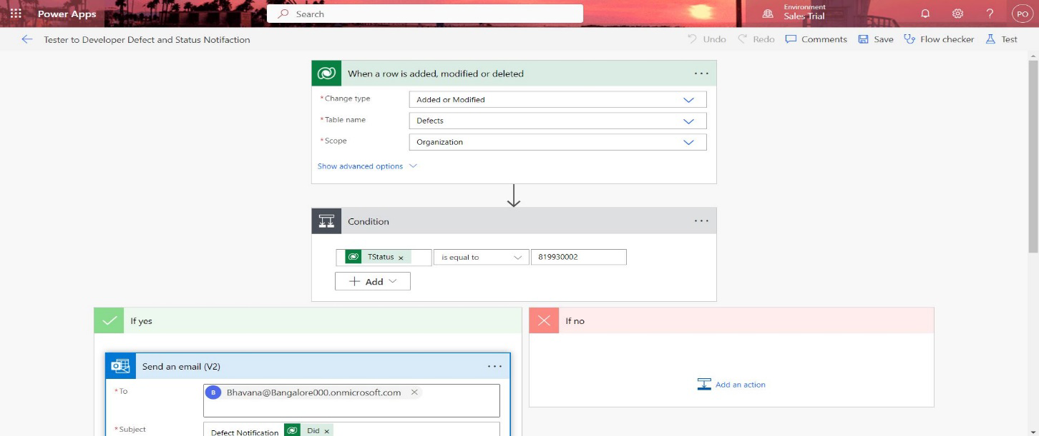

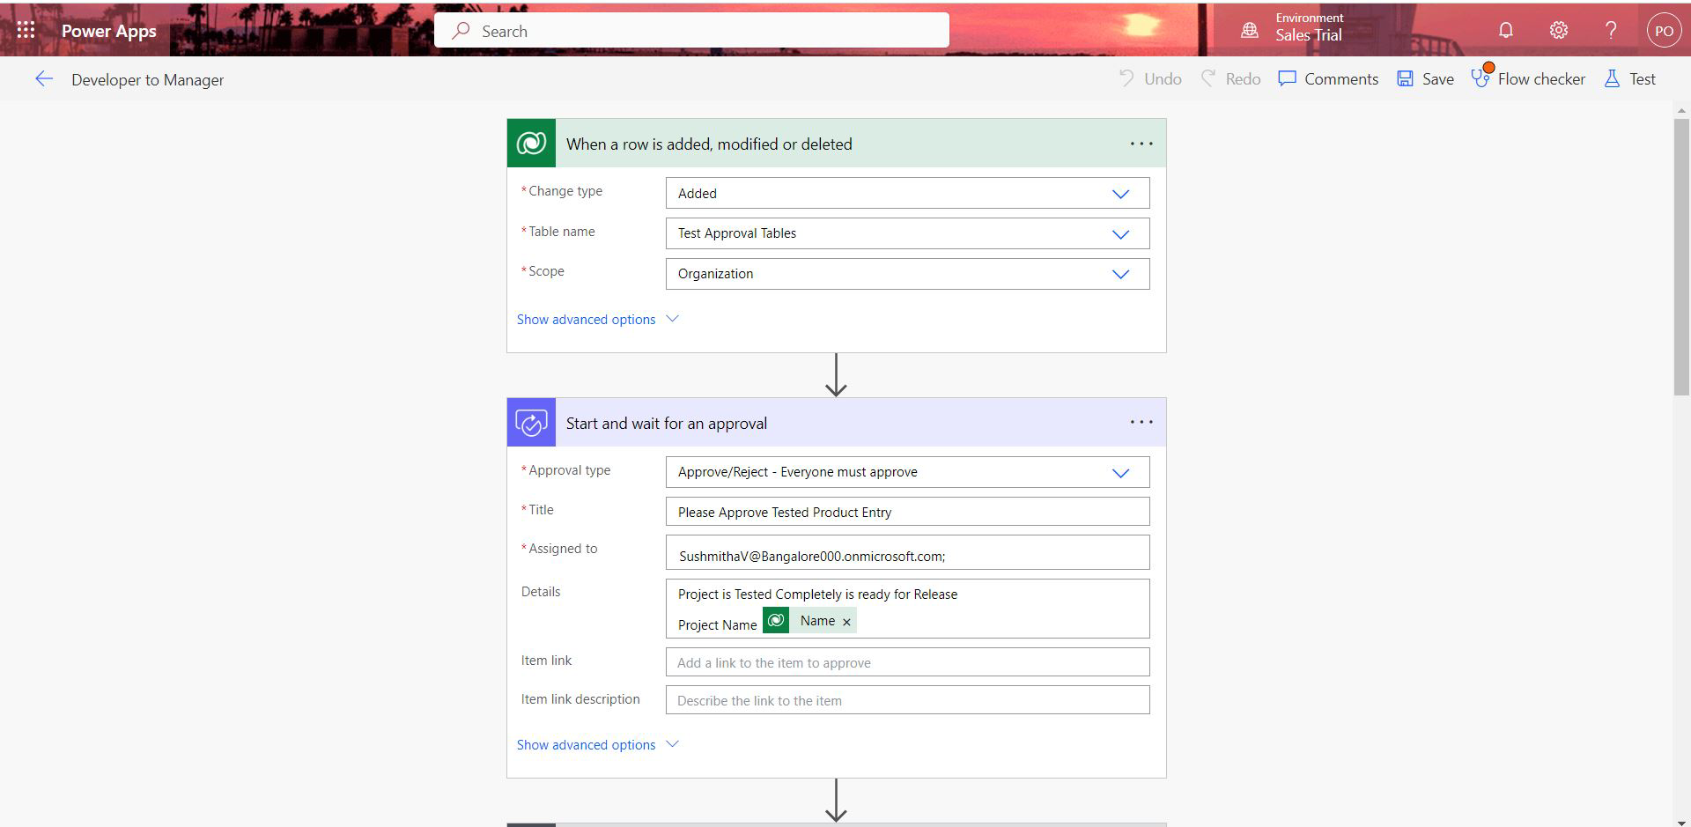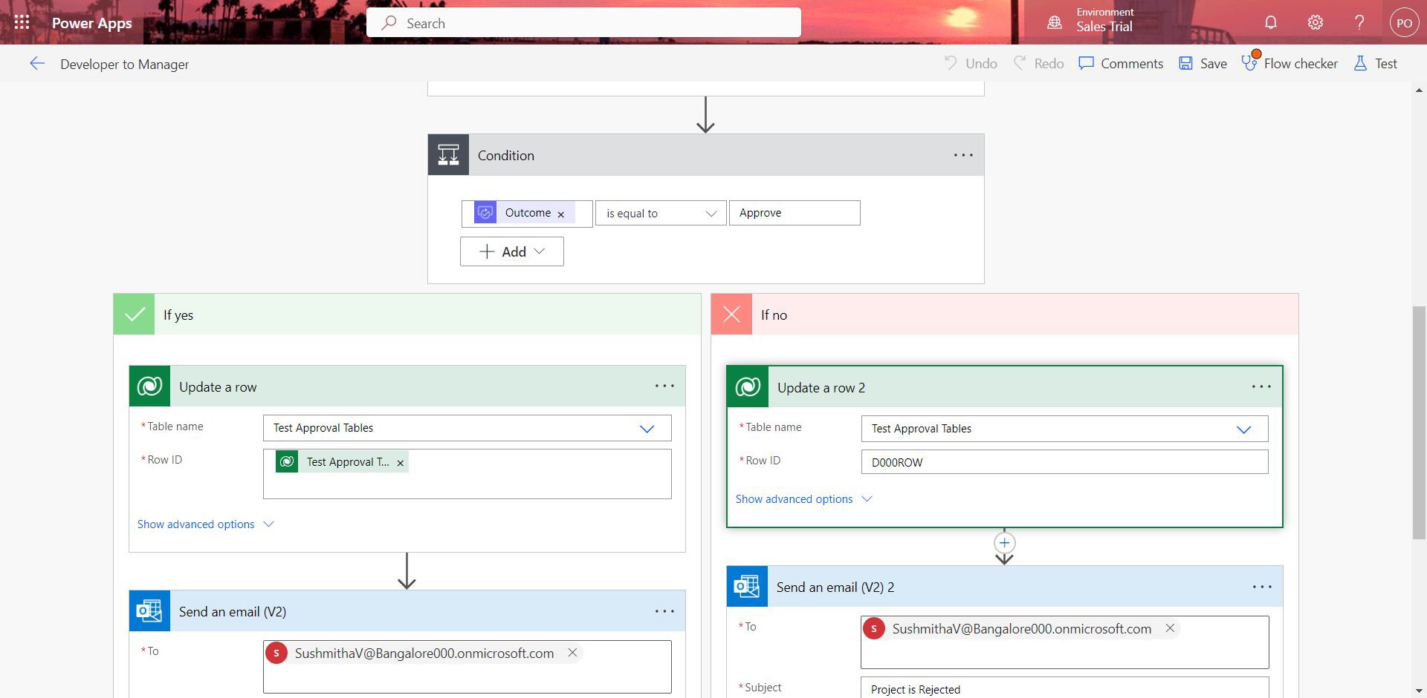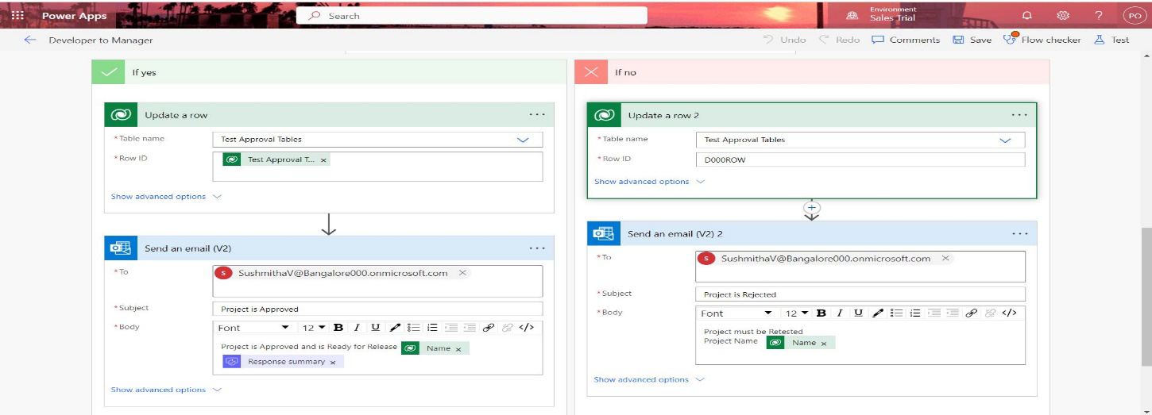

## 13.APPENDICES C-REPORTS & PROJECT PLANNING

